School Supply List for Mrs. Schanz’s Lit/Lang Class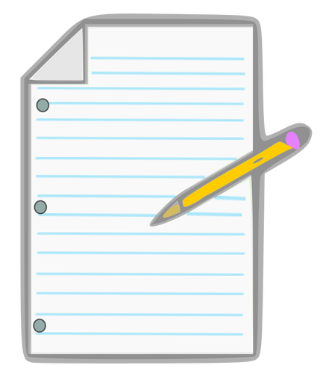

- Colored Pens (Two)
- Pens/Pencils
- Highlighters (Five pack multi-colors)
- 2 inch Three Ring Binder (Can be bigger)
- Loose leaf paper or notebook
- Divider Tabs (to label texts, vocabulary, notes, and handouts)
- Colored Pencilsand/or markers
- A fully charged Chromebook

I am looking forward to seeing all of you! If you have any questions, you can email me at tschanz@sparta.k12.il.us

